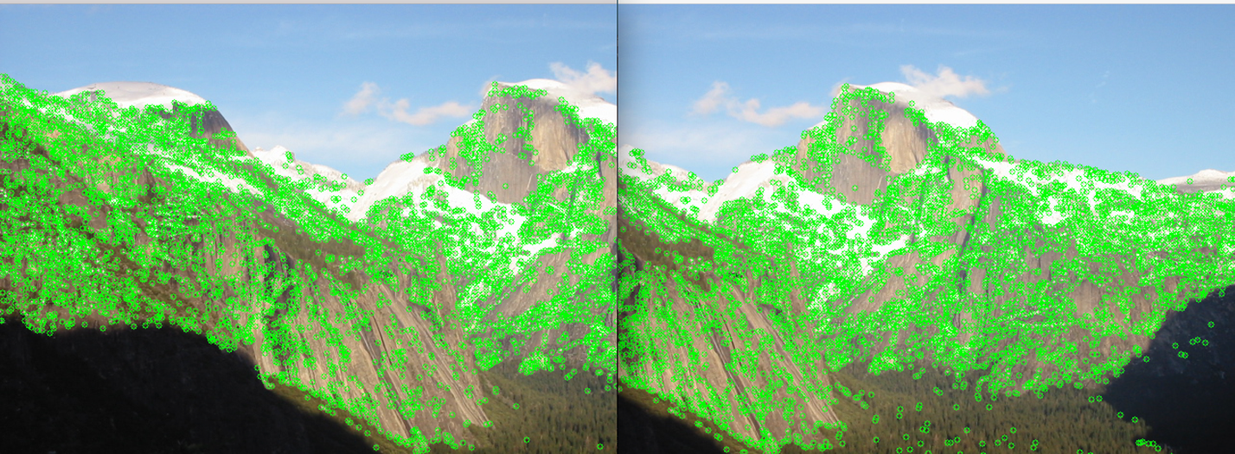

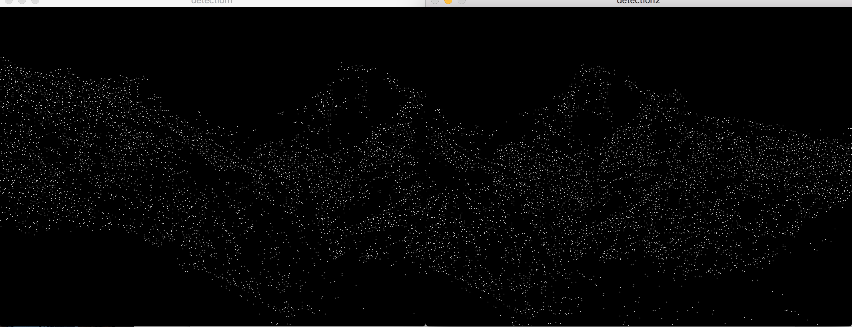

the two pictures above show interest points when I implement interest detector. The first picture I circle interest points in source picture. By using point’s gradient and Harris Matric, I compute interest points showed in the second picture.

For descriptor, I get bunds of patches by locating interest point. I compute the directions and magnitude for each patches which have 128 orientations. Then I normalized the 128 orientations. These are part of orientations in the first pictures.

0.57453835, 0, 0.23798157, 0.33655673, 0.57453835, 0, 0.23798157, 0.33655673, 0.61013144, 0, 0, 0.35740674, 0.61013144, 0, 0, 0.35740674, 0, 0, 0.31897599, 0.45110014, 0.7700761, 0, 0.31897599, 0, 0.66557908, 0, 0, 0, 0.66557902, 0, 0.19494359, 0.27569187, 0.53452247, 0, 0.3779645, 0.53452247, 0.53452247, 0, 0, 0, 0.86285627, 0, 0, 0, 0, 0, 0, 0.50544947, 0, 0, 0.31897599, 0.45110014, 0.7700761, 0, 0.31897599, 0, 0.7700761, 0, 0.31897599, 0.45110014, 0.31897599, 0, 0, 0, 0.63060188, 0, 0.18469901, 0.26120386, 0.63060188, 0, 0.18469901, 0.26120386, 0.57735026, 0, 0, 0, 0, 0, 0, 0.81649655, 0, 0, 0, 0, 0.9238795, 0, 0.38268343, 0, 0.40527663, 0, 0.16787107, 0.23740554, 0.64268214, 0, 0.33574215, 0.47481108, 0, 0, 0, 0, 0.63245553, 0, 0.44721362, 0.63245553, 0.7700761, 0, 0.31897599, 0.45110014, 0.31897599, 0, 0, 0, nan, nan, nan, nan, nan, nan, nan, nan, 0.63245553, 0, 0.44721362, 0.63245553, 0, 0, 0, 0

Finally, I used the orientations of two pictures to match to each other. Firstly, I used SSD to compute their squared absolute distance between two points. Then I used the SSD to compute the test ratio. I get rid of points of low test ratio and keep high values to make sure two pictures matched. The picture below is my result. We can see three parallel line between the two pictures.

